General comments
Fill in the paper slip on the front of the answer paper as soon as you sit down so you are not wasting your own time. Tear it off and put it to the side of the desk with your ID card so I can collect them when the exam starts without disturbing you.
Also fill in the Name and signature on the edge of the paper and stick it down at the end as soon as the exam is over so you are not holding others up as the papers are collected.
Start each new question on a new page
If you need to go back to a question and add something, make a not that there is more on another page, number the pages and simply say, continued on page X. That way it won’t be missed
Make sure I can read your writing. I’ll give it two goes then give up.
Do not write too much. Structure your answer to avoid unnecessary padding as the padding attracts no marks but takes time.
Don’t make sweeping or any other statements without justification or maybe an example.
Break down the key parts of the question and make sure they are addressed
e.g.
- Explain how a digital certificate protects a web user. Your answer should explain what a certificate is, the process the browser goes through, and the cypher techniques used to validate the provided intermediate and server certificates.

(10 Marks)

To keep your answers concise, you don’t always need to write essay type responses. If it’s a comparison for example, you could basically list the differences and provide a reasonable justification for what you have said. E.g. ex4 Q4b

Diagrams can be drawn freehand. Don’t waste time using a ruler and colour coding unless it is really necessary. The following is perfectly acceptable which is then referenced in the answer using the labels in the diagram.
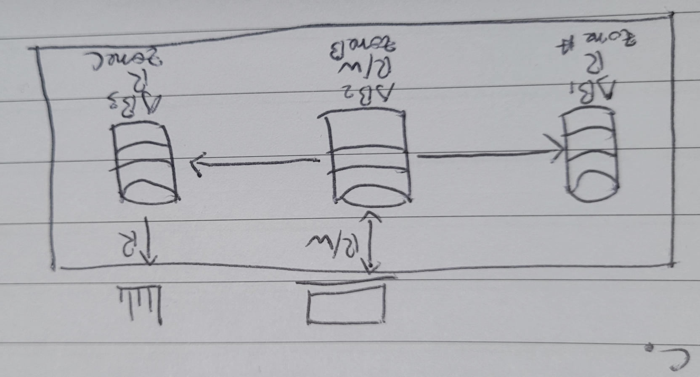

Revision strategy
I have given you a lot of papers and it is a very broad module, so I suggest you focus your time practicing the following questions. Read the notes on that topic. Write an answer. Time yourself. Work on roughly 1 marks per minute. Copy the question and your answer into copilot or whatever, and ask it to review your answer based on the question. Learn from that and apply that learning to the next question you try. If you are not sure if AI is correct, try more than one or contact me and I’ll advise.

Revision questions from exam papers
2022-23 main
Q2b, Q6b
2022-23 resit
Q1a, Q2b, Q2b, Q4, Q6
2023-24 main
Q1a, Q2b, Q3a, Q4
2023-24 resit
Q2a, Q3a, Q3b, Q3d, Q4b, Q5a, Q5b, Q6c
2024-25 main
Q1a, Q3b, Q3c, Q4b
2024-25 resit
Q1a,b,c, Q2a,b,c, Q3b,c, Q4c, Q5c

New topics this year so not covered in previous papers so make sure you thoroughly understand them:
- Bastion host
- Event Notification and Event Carried State Transfer patterns (thick and thin events)
- Network peering
- 3-tier architecture
- SQL injection

